InLab Workshop Extra Credit – 25 Points
This worksheet is designed for you to record and report about the workshops you have attended. To prepare for the workshops, review the tasks below. Make sure you get a picture of yourself attending the Zoom workshop. You will need to include this along with the PDF registration tickets you will receive via email.
Step 1: Fill out the table below
Workshop Title | Workshop Date | Facilitator Name | Question I asked the facilitator | Response from the Facilitator to My Question

Step 2: Write up a summary for each workshop
Workshop Title | Workshop Date | Facilitator Name | Workshop Summary: What was the workshop about? How long did the workshop last for? How many other people attended? What did I learn? Would I recommend the workshop to others? Explain your answers
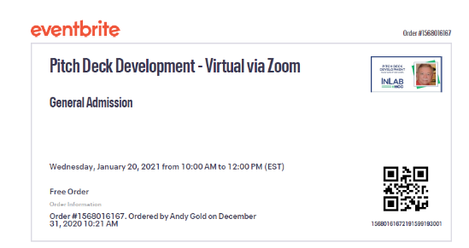
Step 3: You will receive an email confirmation after you register for each event. That email will contain a PDF ticket, like the one shown on the left. You must attach each of the PDF tickets to your summary, along with this document and try to include a picture of you attending the workshop (Take a picture of yourself on the screen).
Step 4: Send an email to the facilitator after the workshop has ended, thanking them for the presentation. Make sure to BCC or CC me (agold3@hccfl.edu) with that email.

