Adjectives
Describe It!
An adjective is a word that describes a noun.
Write three adjectives that could describe each picture.
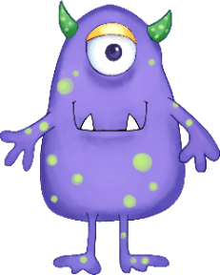

Adjectives that compare two things usually end in er. Adjectives that compare three things usually end in est.
If an adjective ends in a consonant and y, change the y to i and add er or est.
Fill in the missing adjectives below.
Adjective | Adjective that Compares TWO | Adjective that Compares Three or More
bright | brighter
 | faster
 |  | happiest
 | nicer
busy
 | crunchier
 |  | sweetest

