Lab Report Outline

What is a Lab Report?
A Lab Report is a detailed account of an experiment including its methods, results, and conclusions. The lab report should attempt to answer questions raised during the introduction.

Audience & Purpose
Before starting any writing assignment, identify both the audience and purpose of the piece.

Audience
- Scientists (Peers) – Other Scientists interested in similar work who could potentially use your discoveries for their own experiments.

- Professors – your professor will determine the quality of work in both your research and documentation of your research.

Purpose

There are several reasons to write a report. Two of the most common are to inform or to persuade.
- To Inform – provide information in an objective, straightforward manner that aims to present new material to the audience that is clear, thorough, and concise.

- To Persuade - this essay/report aims to convience the audience of a particular stance. For a lab report, this would be a conclusion you draw from your experiments that point toward a particular conclusion you wish the audience to understand.

Why This Format?
The report revolves around the solving of a specific question, described in the introduction and answered in the discussion. A basic outline is shown below:

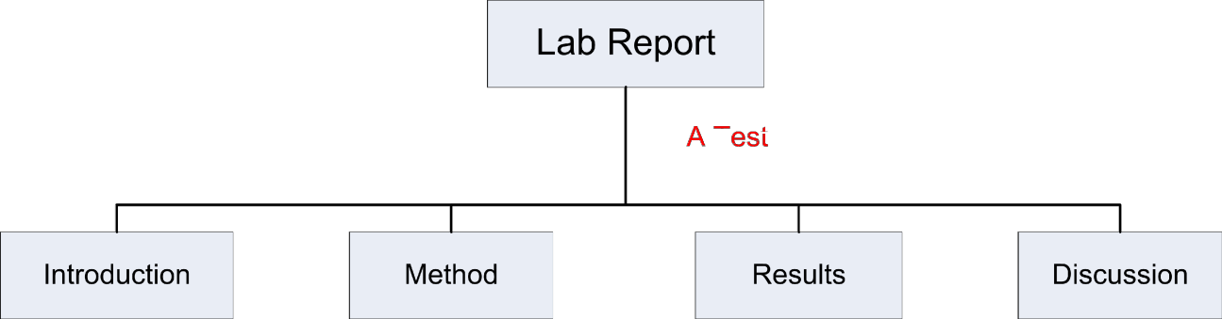
The Test

What and Why How What you found What it means

Lab Report Elements
A report is created using these characteristics:

Name, Title, Page Number, & Date

This document requires Name, Title, Page Number, and Dates. These are essential elements of formatting. Place your name or title with the page number in the header.

Standard Formatting

Lab reports follow standard academic formatting guidelines. These include 12pt font, 1” margins, and headings which subdivide the information into manageable
sections, with one heading per page minimum. Lastly, scientific reports are often written in third person passive voice.

Graphic Numbering

Lap reports use visuals. Each graphic, such as: figures, tables, pictures, equations, etc., is labeled and numbered sequentially. Word will manage this task for
you—search Help for Captions and Cross-references. Examples of this include: Figure 1.1, Table 2.3, Picture 1.3, etc.

IMRD Format

This document follows the IMRD traditional report writing standard. It contains the following sections in this order: Introduction, Methods, Results, and Discussion.
Introduction provides background and the question addressed, methods describes how that question was answered, results show the resulting data from the experiment and discussion is the author’s interpretation of those results. Often results and discussion are combined.

Third Person Passive Voice

This document encourages passive voice. In passive voice, the subject of the sentence does NOT do the action of the verb, the action is done to the subject. The third person perspective tells a story without detailing any person’s thoughts and gives you only an objective point of view.

General Outline for a Lab Report:

Report Sections |  |  | Explanation
A.1 | Title Page
A.2 | Abstract
A.3 | Table of Contents
A.4 | Introduction | - Background / Theory  - Purpose  - Governing Equations  - Discovery Question (DQ) | In this section, you describe what you are trying to find and why.  Background and motivation are used to provide the reader with a reason to read the report.
A.5 | Methods | - Experiment Overview  - Apparatus  - Equipment Table  - Procedures | In this section, you explain how question addressed is answered. Clearly explain your work so it could be repeated.
A.6 | Results | - Narrate (like a story)  - Tables and Graphs  - Equations in Variable Form  - Uncertainties  - Units!  - Indicate Final Results | In this section, you present the results of your experiment. Tables, graphs, and equations are used to summarize the results. Remember your audience.
A.7 | Discussion | - Answer DQ  - Theoretical Comparison  - Explanation of Anomalies / Error  - Conclusion / Summary | In this section, you explain and interpret your results. Insert your opinion, backed by results. Discuss issues you had and how this could be corrected in the future.  The conclusion is a summary of your results and discussion.
A.8 | References

