The Ultimate Unabridged Annotated Bibliographies Guide
If you have just received an assignment that requires an MLA annotated bibliography or APA annotated bibliography, you may be wondering where to start. This annotated bibliography guide is here to help answer all of your questions and includes step-by-step instructions on how to do an annotated bibliography in MLA style or an APA annotated bibliography. You will also find a sample MLA annotated bibliography, a sample annotated bibliography APA template, real-life examples, and opportunities to practice what you have learned.
The MLA (Modern Language Association), one of the most significant scholarly organizations in the United States, is not associated with this guide. All of the information provided here, however, offers direction for students and researchers who use MLA style in their work.
The American Psychological Association is also not associated with this guide, and they do not have required or recommended guidelines or specifications for creating an annotated bibliography. However, we’ve included it since some students may still find it beneficial to add annotations to bibliography done in this style. The structures and templates on this page were created by the certified, in-house librarians at EasyBib.com.
If you’re simply looking for an example of an annotated bibliography, scroll down towards the bottom of the page. We’ve included screenshots to provide a visual for those of you who need help with the structure and styling of an annotated bibliography. If you’re looking for a variety of annotated bibliography topics, and you’re truly searching for the answer to, “what is an annotated bibliography?,” then continue reading!

What is an APA and MLA Annotated Bibliography?
A bibliography is a complete list of the sources that were used to complete a research paper or project. Depending on the style guide you follow, you may also see this called a Works Cited or Reference List. Each listed source, or citation, shares information about the author, title, publishing year, and other details that serve to credit the original authors whose work informed your research. These details also help other students and researchers find and read the source materials.
There are few limitations to the types of sources that you can include, and your list may consist of sources that range from books and academic journals to food labels and tweets. When your research is related to a scholastic assignment, you should always verify your instructor’s requirements for the types and number of sources to include, as well as the style you should adhere to when formatting your paper and bibliography.
An annotated bibliography in MLA and an APA format annotated bibliography includes a concise explanation of each listed source, known as an annotation. Depending on the assignment, this annotation may be solely descriptive, or analytical.
An abstract and annotation should not be confused; they differ in both their substance as well as their placement in a paper. If you would like to learn more, this link further explores the difference between an abstract and an annotation.
This resource provides additional information on how to write a bibliography with annotations in other formats. You can also take advantage of the plagiarism checker and bibliography tools that come with EasyBib Plus to help you create your reference lists.

Why Include Annotations?
Before you learn how to make an annotated bibliography in MLA style, or how to write an annotated bibliography in a way we suggest for the American Psychological Association, you may be wondering why you need to. Sometimes instructors want you to create and include annotations in your bibliography, either as part of an assignment or as an assignment unto itself. Understanding the purpose of this approach to your references list can help to ensure that you gain all of the benefits that the annotated bibliography process provides.
As a student, this method will help you develop or hone your research skills, providing you with practice not only in locating sources but also in analyzing and evaluating them for relevance and quality.
Your instructor will gain insight into your research abilities, as well, allowing them to assess your work more thoroughly. If you plan to publish your research, this comprehensive approach to detailing your sources will provide readers and other researchers with a substantial directory of resources to evaluate for their own work. Whether you’re publishing or submitting your annotated bibliography, make sure your spelling and wording is correct! If you need to brush up on any parts of speech topics, check out our interjection, determiner, and adverb pages!

Formatting MLA Annotated Bibliography Entries
Your field of study or instructor will guide your decision on whether to format your annotated bibliography in MLA or a different style. In this guide, you’ll find an example of an MLA annotated bibliography as well as an APA sample annotated bibliography. For guidance on creating entries in MLA format, APA format, and more styles, check out EasyBib.com’s library of resources or try our MLA annotated bibliography maker.
The following is an annotated bibliography example in MLA format for an article on the MLA website. This example shows what the entry will look like without an annotation:
“What Guidance Should I Give My Students for Preparing an Annotated Bibliography?” The MLA Style Center, The Modern Language Association, 4 Nov. 2016, style.mla.org/annotated-bibliographies/
Here is the same entry with an annotation. If you’re wondering how to do an annotated bibliography, as in the actual written piece, you’ll learn how to create an annotation in the next section:
“What Guidance Should I Give My Students for Preparing an Annotated Bibliography?” The MLA Style Center, The Modern Language Association, 4 Nov. 2016, style.mla.org/annotated-bibliographies/.
This article offers brief and clear directions for MLA formatting of a bibliography with annotations. Citing James Harner’s On Compiling an Annotated Bibliography, it provides guidelines for writing annotations that can be applied to either paraphrase or commentary form. It also demonstrates how writing annotations can benefit students who are tasked with researching a subject and offers instruction on the organization of entries and acceptable page titles. While the advice is tailored to respond to a question posed by an instructor, students and researchers may also benefit from the guidance that the MLA provided.

Writing the Description
If you are creating a list of references with annotations as part of an assignment, forming the written portion of your annotation begins with identifying the format requested by your teacher or professor. The summary of an annotated bibliography in MLA style may be written either as short, direct phrases or as complete sentences. Your instructor will advise you of which approach you are required to take.
Your annotations should include either the main points from the source, as well as the topics covered, the approach used and any findings, or your critical evaluation. A standard annotation is 150-200 words or approximately one paragraph. Take care not to include any unnecessary details, as the goal is to summarize each source as succinctly as possible and, in some cases, evaluate them.
Here is an MLA annotated bibliography example which contains the citation as well as a summary for the book The Elements of Eloquence: Secrets of the Perfect Turn of Phrase by UK author and blogger Mark Forsyth:
Forsyth, Mark. The Elements of Eloquence: Secrets of the Perfect Turn of Phrase. Penguin Books, 2014.
The author, Mark Forsyth, examines the rhetorical devices used in the English language, analyzing the patterns and formats that create memorable quotes. He traces the history of rhetoric to the Ancient Greeks, and provides an abridged timeline, following their use and evolution through to modern day. The author also explores the broader subject of persuasion and maps out the role that the figures of rhetoric play in it. In all, he examines over thirty devices, dissecting notable passages and phrases from pop music, the plays of William Shakespeare, the Bible, and more to explore the figures of rhetoric at work within each of them. Thorough definitions accompany this examination of structure to demonstrate how these formulas have been used to generate famously memorable expressions as well as how to reproduce their effects.
For an annotated bibliography APA example, we’re going to use the same exact description as above. The only thing we’re going to change is the structure of the reference. For an APA bibliography, the reference needs to be an APA citation, and the description can be formed the same way as above.
Here’s what the APA book citation for The Elements of Eloquence: Secrets of the Perfect Turn of Phrase looks like:
Forsyth, M. (2014). The elements of eloquence: Secrets of the perfect turn of phrase. New York: Berkeley.
Additional annotated bibliography examples in MLA, and an APA annotated bibliography example, are found further down the page. For more information on annotations, check out this informative site. If you’re looking to strengthen your writing in general, reading these grammar guides could be a good start.

Analyzing Your Sources
As seen in the annotated bibliography example in MLA format above, each entry should include summarization or analysis of your source. If you have been tasked with writing annotations as part of a research paper or project, you can begin to create this element while you identify and analyze your sources. Not only will this approach help you to hone your research skills and identify sources that are relevant and useful for your topic, but you will also save time. When done in this manner, both your citations and annotations will be nearly complete before you begin to write the body of your paper.
Analyzing your potential sources requires a two-pronged approach that first evaluates the author, publication, and date, and then examines the content.
When conducting your initial assessment of the source, consider some of the following questions to guide your appraisal:
- What qualifies the author to write on this subject?
- Is the author affiliated with a reputable institution in this field?
- Is the author credentialed or otherwise considered an expert in this field?
- Is this source current?
- Is this the most recent edition?
- Is the publisher reputable?
- Is the journal reputable?
Once your primary evaluation is complete, you will move on the assessing the content itself. Consider some of these elements as you review each source:
- Who is the intended audience?
- Is the author presenting her opinion or interpretation as the truth, or stating facts?
- What supporting evidence does the author provide?
- Did the author perform the research, or curate and present the research of others?
- If the author used the research of others, are the sources the author cites credible?
- Are there errors or omissions of fact?
- Is the author writing objectively and without bias?
Also, consider the value each source provides to you:
- Is the information helpful for your particular assignment?
- Does it help answer your research question(s)?
- Is this source different from your other sources, or does it repeat information you already have?
- Is the source providing you with a different perspective on your topic, or changing your beliefs or thinking about your subject?
To make it easier for you to create your reference page, write your notes in the format you will be using when you construct this part of the assignment. Once you have identified all of the sources you wish to include, you will merely need to insert what you have already written on the page and write your introduction, which is explained in the next section.
Click here for additional information and a supplementary annotated bibliography sample in MLA style. Or, scroll down and check out our visual example of annotated bibliography below.

Organizing Your MLA Style Annotated Bibliography
The MLA Style Center provides the following guidance for the organization of your completed list of references:
- Your reference page should have the title Annotated Bibliography or Annotated List of Works Cited.
- Your sources may be organized alphabetically by author or title, by the publication date, or by subject. Ask your instructor how they would like this organized if they haven’t provided specific guidance.
- Your annotations should typically not exceed a single paragraph.
- If you do exceed one paragraph, indent each new paragraph and separate with a single space between them.
- The entire Works Cited page or pages should be double-spaced.
The MLA follows the rules set forth in James L. Harner’s On Compiling An Annotated Bibliography, 2nd Edition, which they published in 2000. Harner submits that the typical organization for this type of work “…consists of three parts: prefatory matter, entries, and an index” (7). Following this, he adds, however, that “an electronic bibliography rarely includes an index” (7).
The “prefatory matter” functions similarly to an introduction, and “typically consists of an introduction, an explanation of editorial procedures, acknowledgements, and separate lists of abbreviations, major reference sources searched, and the subject author’s works” (7). He expands on this, “You must explain – and, if necessary, offer a rationale for – the taxonomy, the kinds of works included and excluded, and the chronological span (especially terminal date) of scholarship covered” (7).
Your instructor or school may have additional or different requirements for how you format and organize this page. If your teacher or professor requires an introduction, they may identify specific points to include or exclude which deviate from Harner’s definition, so it’s essential that you verify your understanding of the assignment before beginning.
If you are including an introduction, this should be added below the page title and precede your citations and annotations. If you are required to format your references in a manner other than MLA, EasyBib.com’s style guides can help you with many common styles. While you’re at it, check out their conjunction, preposition, and pronoun pages to help keep your paper in mint condition!

Organizing Your APA Style Annotated Bibliography
As stated numerous times throughout this page, the American Psychological Association does not have a required or recommended way to structure an annotated bibliography. Since there are no set rules, you may be wondering how to create an APA bibliography. If your teacher or professor requests an APA bibliography, don’t worry, here are EasyBib.com’s recommendations:
- The annotated bibliography format for the written descriptions can be structured similarly to the Modern Language Association’s guidelines, found above.
- The structure of the references should be different. Make sure you create your references according to APA’s guidelines. If you need some help, here’s a great APA citation website, which shows how to create references for electronic sources. We also have a page on developing a reference for an APA journal. Need other source types? Check out the other helpful pages on EasyBib.com.
- Title your page, “Annotated Bibliography.”
- Organize the page of your annotated bibliography according to the same guidelines shown in APA Works Cited.
- The entire page should be double-spaced.
If you’ve made it this far on the page and you’re still scratching your head, wondering, “What is annotated bibliography?” “Why do I need to make one?” “What does one even look like once it’s typed out on the page?” These are all great questions. In the next section, you will find an annotated bibliography MLA example and also an annotated bibliography example APA visual, which includes the full page formatting. You will also have the opportunity to practice creating an annotated bibliography example in MLA style. We’ve even included instructions on using EasyBib.com’s annotated bibliography maker! Hopefully, the examples of annotated bibliography images below will help clear up any confusion!

Annotated Bibliography Example: MLA & More
If you are creating an MLA annotated bibliography, EasyBib.com’s MLA annotated bibliography generator can save you time and help you format your entries correctly. You can create entries for websites, books, videos, databases, dictionary articles, and many other types of sources.
In addition to forming the citations, you can also enter your annotation text to produce the complete entry for each source. The process for this is simple. You can follow along below to practice creating one:
First, select the style you will be using to format your paper. For this exercise, you will choose MLA 8.
Next, choose your source type from among the 50+ available options. For this example, we will use the acting career of Keanu Reeves as our research topic and use the movie Point Break from 1991 as our first source. To cite this film, you would select the option for film/video. As you follow along, pick the option that is suitable for your source if you are using a different example.
Enter the title of your source or, if you are citing a website, you may enter the URL (now would be a great time to peek at how to cite websites in MLA). After you enter the title or URL for your reference, EasyBib.com will scan for titles that match it and provide you with a list of results. Select “cite this” next to the listing that matches your source.
You will then have the option to add additional relevant or necessary information. For our sample topic, we will specifically cite Keanu Reeves as the performer and Kathryn Bigelow as the director.
After entering any additional details, you have the option to expand your entry and include an annotation. To do so, select “add annotation” and type your summary or analysis into the text box. If you took notes during the research stage using the format of your paper, this might be as simple as copying and pasting your already written summary or critique. Once you have entered all of the necessary information, select “create citation” to generate the complete entry. You can then copy and paste this into your document.
Here is the entry for the example we just walked through with annotation written in commentary form:
Point Break. Directed by Kathryn Bigelow, performance by Keanu Reeves, 20th Century Fox, 1991.
Reeves’ role as rookie FBI Agent Johnny Utah in Point Break marks the turning point in his Hollywood film career. While he’d risen to fame due to the success of the Bill & Ted franchise, his status today as an action star began when Point Break provided him with the material to establish himself as capable of portraying more than the lovable but unserious characters of his previous starring roles. In a parallel arc, director Kathryn Bigelow’s career also sees a shift beginning with Point Break, establishing her within the traditional action genre as a serious director capable of creating high-action and visually memorable films. While Point Break leaves plenty to be desired in terms of dialogue, it afforded Bigelow and Reeves the opportunities to showcase themselves and their talent in new ways that still echo in their work today.
Here is another MLA annotated bibliography sample that shows how each entry will appear within a formatted reference page. This entry was created using the novel Sarah’s Key by Tatiana de Rosnay as the referenced source:
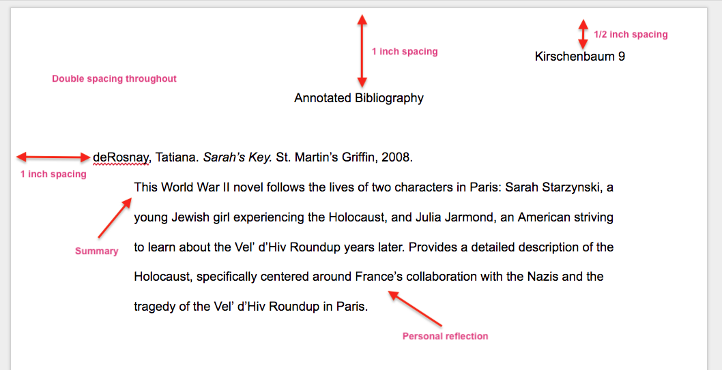
Note that this page does not contain an introductory paragraph. If you are including a prefatory section, it should reside between the page title and the initial entry.
Next is an example of the same source in APA style. Even though The American Psychological Association does not support the creation of bibliographies that include annotations, many schools and professors expect their students to include summaries or commentary alongside their citations in APA style. EasyBib.com recommends an annotation similar to the one below:
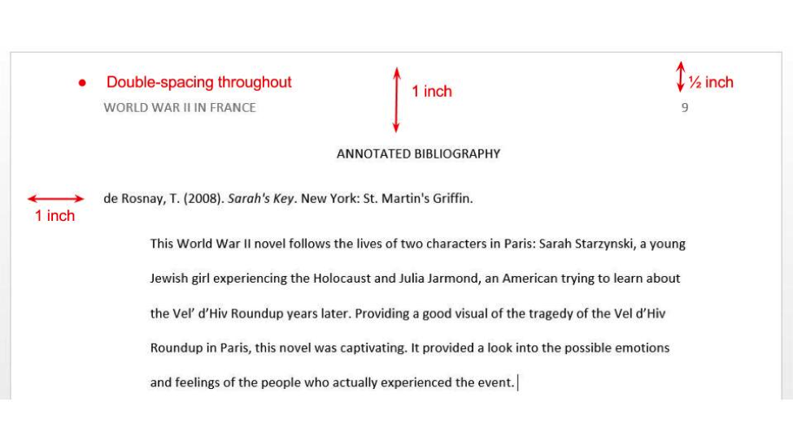

MLA Annotated Bibliography Template
Students and researchers who type their research notes can save time by using an annotated bibliography template in MLA format while reviewing and analyzing sources. By adding the relevant information into a pre-formatted template, you’ll create a resource that helps you when you begin writing your paper in addition to saving time by completing your references and summaries alongside your research.
Students who prefer to take notes by hand can employ a modified version of this approach, with an additional step required to transfer your handwritten and formatted references from your notebook to populate your reference page.
To create an annotated bibliography MLA template, copy the following details into the program in which you will take notes or handwrite it on the top margin of a page in your notebook. For each source, use this template to guide you as you identify the necessary details and insert them into your notes:
- Author (last name, first name).
- Title of source.
- Title of the container,
- Other contributors (names and roles),
- Version,
- Number,
- Publisher,
- Publication Date,
- Location of the source (such as URL or page range).
- Summary or Analysis.
The MLA 8 model for MLA works cited entries offers a single format for all source types, and a great deal of flexibility to include the information most relevant to your topic and omit that which isn’t.
In the sample annotated bibliography in MLA style that we created in the previous section, for example, we included Keanu Reeves because it was his performance that was relevant to our research. Director Kathryn Bigelow is also included, both to credit her for the work and for details of the actor’s performance that her direction may have influenced. Patrick Swayze, who had a co-starring role in the film, is not listed because his performance was not relevant to our research.
For more examples of an annotated bibliography in MLA format, the MLA Style Center provides practical examples and answers to frequently asked questions. Learn more here. Also, here’s a guide if you’re looking for more on the related topic of MLA in-text & parenthetical citations.

Bibliography Template for APA
Students and researchers who are still asking themselves how to piece together an annotated bibliography, or still questioning what is a annotated bibliography, could probably benefit from a template, similar to the one above. This one, however, is for those of you who are tasked with creating an annotated bibliography in the style created by the American Psychological Association.
The tricky thing about this specific style though, is that every reference is styled differently. Books, websites, journal articles, newspaper articles, and many others each have their own reference structure. For most sources though, author names and dates are generally found in the beginning of the reference. The titles of sources are styled differently depending on the source type, as some titles are written in italics and some are written with quotation marks. In addition, sometimes words include a capital letter at the beginning, and sometimes only lowercase letters are used. Some references require a bracket after the title, too, to showcase the medium of the source. For example: The odyssey of Homer [Kindle version] could be used for an e-book version of the book, The Odyssey of Homer.
Most sources found online include a website address at the end. We understand it can get tricky, and it’s very different from the Modern Language Association’s structure for references. Take a moment to either use the other handy guides on EasyBib.com or use our automatic generator to form your references in just a few clicks. Our tools help take the pain away from having to rack your brain to form references properly. Capitals, lowercase letters, italics, quotation marks, punctuation in the appropriate places, it can all be quite overwhelming. Do yourself a favor, and use EasyBib.com’s automatic generator.
Even though there are a lot of different variations, here’s a commonly used structure for sources:
Author’s Last Name, First initial, Middle initial. (Year the source was published). Title of the
source. Retrieved from (insert the website address here)
Underneath the reference, include your summary or analysis paragraph.
Hopefully, this page helped answer all of your “What is an annotated bibliography?” questions. If you’re seeking out an annotated bibliography generator, follow the steps above the annotated bibliography examples.
Looking for additional help with other related topics? Don’t forget about the various beneficial guides on EasyBib.com! Our APA in-text citation guide and our APA parenthetical citation guide are two of our most popular pages. Learn the ins and outs of referencing your work in the body of your paper with our thorough, complete, and reader-friendly guides.

Source
Harner, James L. On Compiling an Annotated Bibliography. 2nd ed. Modern Language Assoc. of America, 2000.

